Instructor: Dr. Jie Shen
Release date: Feb. 15, 2021
Due date: Feb. 22, 2021

Student Name: Demetrius Johnson
*Special note: see my lab uploads of the .CPP and .EXE files for ease of access and testing any of the programs for any question.

Table of Contents
Question 1 3
Source code (USED C++ COMPILER on Microsoft Windows 10) 3
Test data and expected results 4
Question 2 6
Source code (USED C++ COMPILER on Microsoft Windows 10) 6
Test data and expected results 8
Provide an MS word document or a pdf file with the following information: 9

Question 1

Source code (USED C++ COMPILER on Microsoft Windows 10)
// CIS-200-LAB 5 -DemetriusJohnson.cpp : This file contains the 'main' function. Program execution begins and ends there.
//

/*
//Author: Demetrius E Johnson
//Date: 19 FEB 2021
//Last Modification Date: 2-19-2021
//Purpose: create a data type and output its data member contents

*/

/*
Question 1: User-defined Data Type

Define your own data type, REAL44, which means a 4-by-4 float array.

Then, in your main( ), create two instances of this data type:

REAL44 a, b;

for(int i=0; i<4; i++)
for(int j=0; j<4; j++)
{
a[i][j] = i*j;
cout << a[i][j] << “ “;
}

Create a screenshot of the running result.

*/

#include <iostream>
#include<assert.h>
#define ROW 4
#define COL 4
using namespace std;

//CLASS DECLARATION

struct REAL44 { float RealNumber[ROW][COL]; };

//CLASS DECLARATION

int main()
{

cout << "----WELCOME TO THE SIMPLE 4X4 ARRAY OUTPUT PROGRAM------BY Demetrius Johnson\n\n\n";

REAL44 a, b;

for (int i = 0; i < 4; i++)
for (int j = 0; j < 4; j++)
{
a.RealNumber[i][j] = i * j;
cout << a.RealNumber[i][j] << " ";
}

cout << endl << endl << "The program has finished execution....now exiting...thank you....\n\n";
system("pause");

return 0;
}

Test data and expected results

Test Table:
Test # | Valid / Invalid Data | Description of test | Input Value | Expected Output | Actual Output | Test Pass / Fail
1 | valid | Output the values of the REAL44 array attribute | none | See screenshot | See screenshot | pass

TEST 1:
Below is an output based on the 4x4 array data member from the REAL44 Object that I created. It is ran through two for-loops in order to iterate through each element of the array (we need two loops since it has two dimensions: rows and columns), assign a value equal to the multiplication of the current loop iteration values from each loop, and then the element is output to the screen based on the row and column selected by the loop iteration values.

As you will notice, the first 4 numbers output are zeroes; this is because when the outer loop, i, is at 0, it is multiplied by the inner loop (currently at value = 0 as well for first iteration then increments up to and including 3), and thus the output is for element (0,0) → (i,j) = i*j = 0; even when j iterates all the way through before moving back to the outer loop, the value will be output as 0 since → 0*0, 0*1, 0*2, 0*3 → 0 0 0 0. And since we are at iteration 0, then all elements of row 0 in the 2D array will have a value of 0.
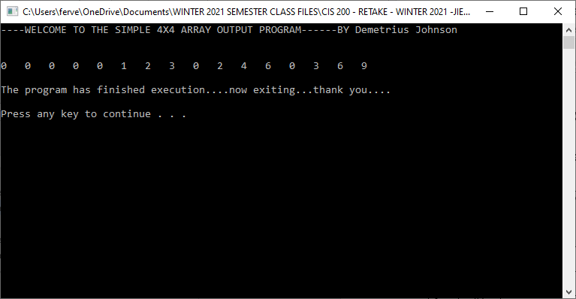

Question 2

Source code (USED C++ COMPILER on Microsoft Windows 10)
// CIS-200-LAB 5 -DemetriusJohnson.cpp : This file contains the 'main' function. Program execution begins and ends there.
//

/*
//Author: Demetrius E Johnson
//Date: 19 FEB 2021
//Last Modification Date: 2-19-2021
//Purpose: demonstrate the use of class constructors and operator overloading

*/

/*
Question 2: Class Constructors and Operator Overloading

Create a class called Student, which contains the following data members:

private:
int x;
protected:
float y;

Class Student should include the following member functions:

(1) Default constructor that sets x and y to 0 and 0.0, respectively
(2) Parameterized constructor that take two input arguments: int a, float b
(3) Copy constructor
(4) Overloading of “=” operator

Implement a main( ), in which you need to design test cases to test each of the above member functions.

Create screenshots to show the results.

*/

#include <iostream>
#include<assert.h>
using namespace std;

//CLASS DECLARATIONS

class Student {

public:

Student() { x = 0; y = 0.0; } //(1) Default constructor that sets x and y to 0 and 0.0, respectively
Student(int a, float b) { x = a; y = b; } //(2) Parameterized constructor that take two input arguments : int a, float b
Student(Student& copyObj) { this->x = copyObj.x; this->y = copyObj.y; } //(3) Copy constructor

Student& operator=(Student &copyObj) {
this->x = copyObj.x;
this->y = copyObj.y;
return *this;
} //(4) Overloading of " = " operator

int get_X_Val(void) { return x; } //need getter function since x and y are inaccessible outside of this class (they are not public data members)
float get_Y_Val(void) { return y; }
private:

int x;

protected:

float y;

};

//CLASS DECLARATIONS

int main()
{

cout << "-------WELCOME TO THE SIMPLE CLASS CONSTRUCTOR AND '=' OPERATOR OVERLOAD DEMONSTRATION PROGRAM ---BY Demetrius JOhnson--------\n\n\n";
//remember a constructor is a function that is called when an object is first declared and needs to be built (memory needs to be allocated for the variable and its data attributes assigned a value)

Student one; //this will call the default constructor --> the object is being constructed and the declaration takes no parameters; attributes will be set to a default value specified in the function
cout << "After initializing 'Student one': Student one --> " << "x = " << one.get_X_Val() << " y = " << one.get_Y_Val() << " //Default Constructor called" << endl << endl;

Student two(2, 2.2); //this will call the parameterized constructor --> the object is being contructed and the declaration includes paramters that will set attribute values to a non-default value
cout << "After initializing 'Student two(2, 2.2)': Student two --> " << "x = " << two.get_X_Val() << " y = " << two.get_Y_Val() << " //Parameterized Constructor called" << endl << endl;

Student three(two); //this will call the copy constructor function
cout << "After initializing 'Student three(two)': Student three --> " << "x = " << three.get_X_Val() << " y = " << three.get_Y_Val() << " //Copy Constructor called" << endl << endl;

Student four = two; //this is a form of initialization using the assginment operator that will call also call the copy constructor function
cout << "After initializing 'Student four = two': Student four --> " << "x = " << four.get_X_Val() << " y = " << four.get_Y_Val() << " //Copy Constructor called" << endl << endl;

four = one; //this will call the overloaded assignment operator (=) function
//although this is overloaded, since there are no pointer attributes and the function I wrote essentially does a memberwise copy,
//it function as the default =operator (non-overloaded)

cout << "After setting 'four = one': Student four --> " << "x = " << four.get_X_Val() << " y = " << four.get_Y_Val() << " //Overloaded Assignment Operater (=) called" << endl;

cout << endl << endl << "The program has finished execution....now exiting...thank you....\n\n";
system("pause");

return 0;
}

Test data and expected results

Test Table:
Test # | Valid / Invalid Data | Description of test | Input Value | Expected Output | Actual Output | Test Pass / Fail
1 | valid | Test the use of the three types of constructors: default, parameterized, and copy. | See screenshot | See screenshot | See screenshot | pass

TEST 1:
Below, you will notice something special; the assignment operator acts exactly like the copy constructor when an object is initialized using “=” instead of (object_to_copy).
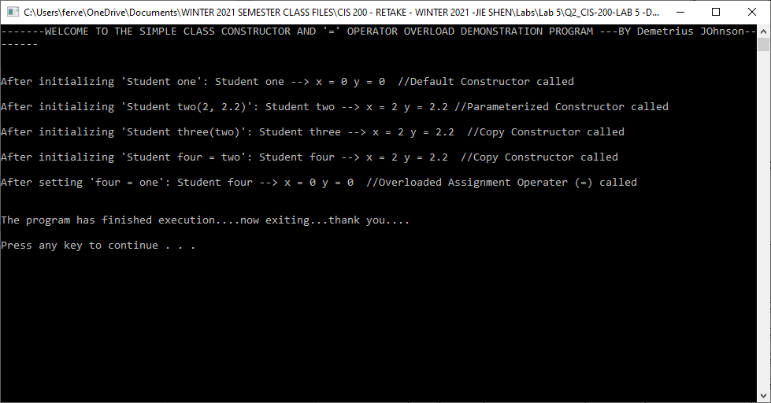

Submission

Provide an MS word document or a pdf file with the following information:
- Cover page with lab number and title, your name, date
- Test data and expected results
- Test case design and screen shots
- Insert the source code and screenshots into the word document
- You should submit your work through Canvas site for cis 200 lab.
- The filename of the word document should follow the convention: FirstName_LastName_Cis200Lab5.doc or pdf.

